Storyboard
CIS 60.1 Roman Sery

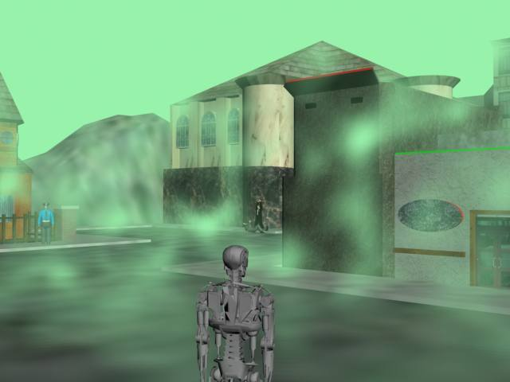
You arrive, taking in the poisonous atmosphere of New Orleans. The Humans are not even fazed by the presence of a stranger among them. You have to do something about your visual sub-processor before continuing the mission.

You seek out a human, a storeowner that appears to be different from the rest. He’s gentler and kinder; he helps you even after your mysterious explanations.
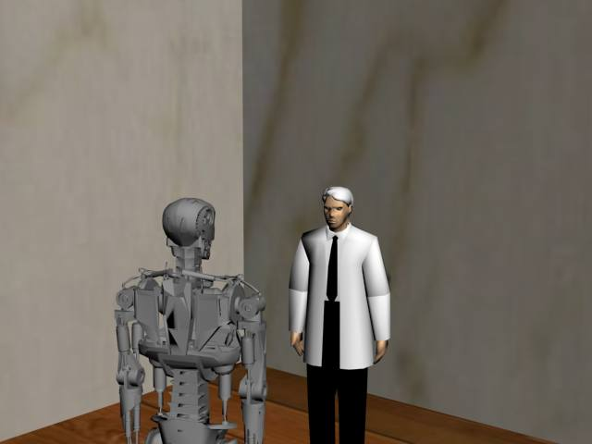

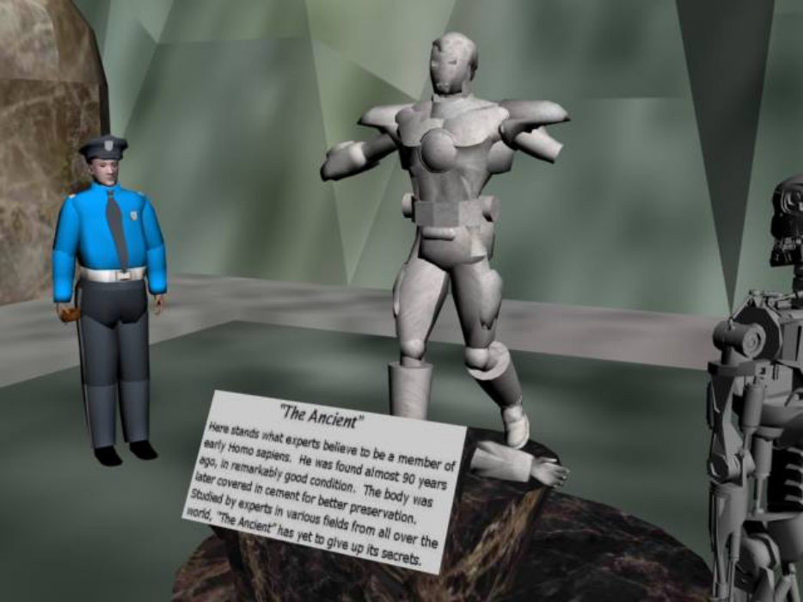
You follow orders, coming upon what the humans refer to as “The Ancient”. The inspector appears to have died long ago; only the few damaged files in his memory banks remain. You retrieve the files, still confused over the suspicious motives of your superiors and the reasons behind your short-term memory loss.

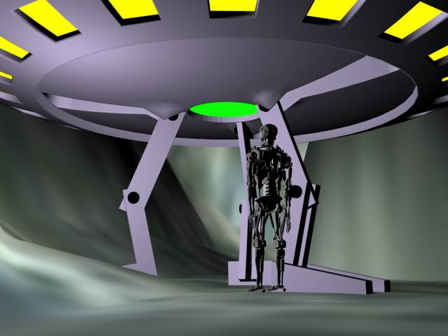
Returning to your ship, you upload the data you’ve collected. It seems your superiors are done holding your hand, they order you to explore the city and study the humans on your own.

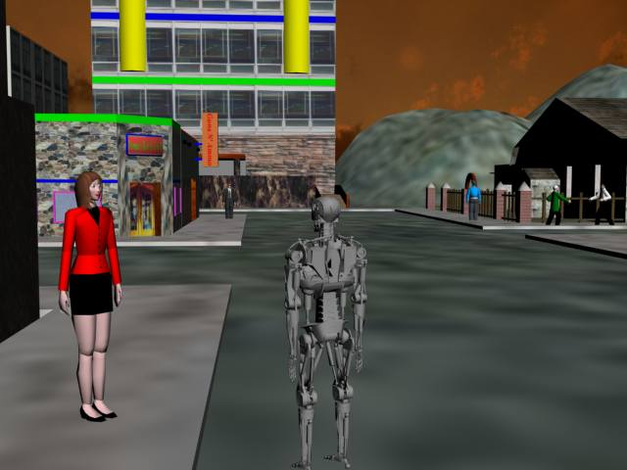
You come across a woman named Jane; she claims to be your wife! You try to be polite in the face of the woman’s obvious distress and leave, thinking about your real wife back home. Clearly these humans don’t take good care of their mentally disturbed.

As you walk away, a wave of emotions flood your thoughts. You seem to have memories of Jane. The glimpses of the two of you together in your mind seem to be from some other lifetime. But yet they in every way contradict what you know.

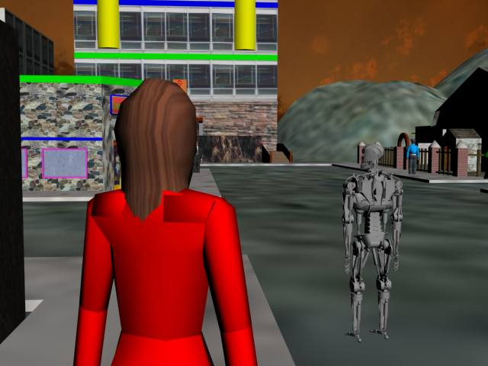

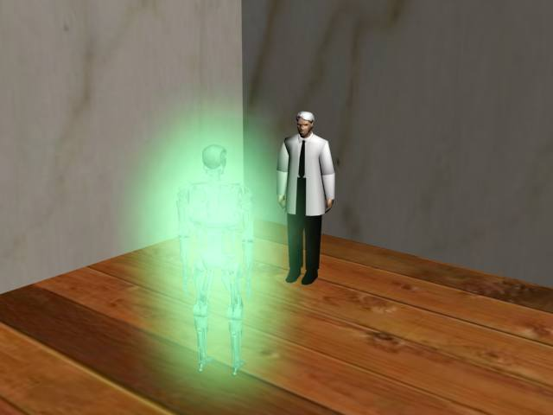
Not knowing whom else to turn to, you seek the aid of the human that helped you before. You have to find out what is going on with your memories and who Jane really is. You accept the “drug” given you. Your vision starts to blur, everything starts changing colors and glowing, and your head feels like its about to explode. The process is almost complete…

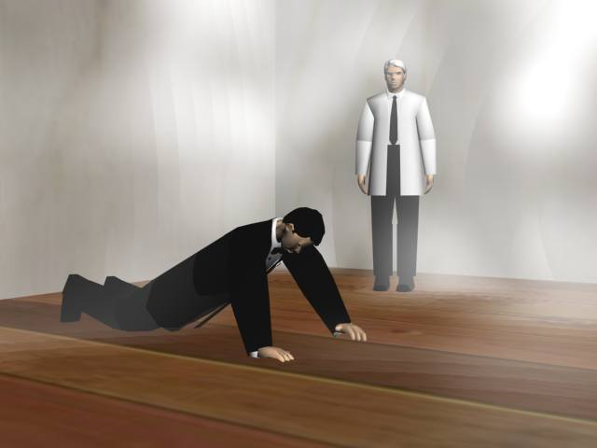
Coming to you realize that something’s different…the way your body feels, the way you blink your eyes. You realize that you yourself are human! The clear memory of Jane is the first thought in your mind, followed by your “fake” memories, the ones implanted in to your head by the real aliens. You know that whatever you can do to get your life back, you have to do it with Jane.

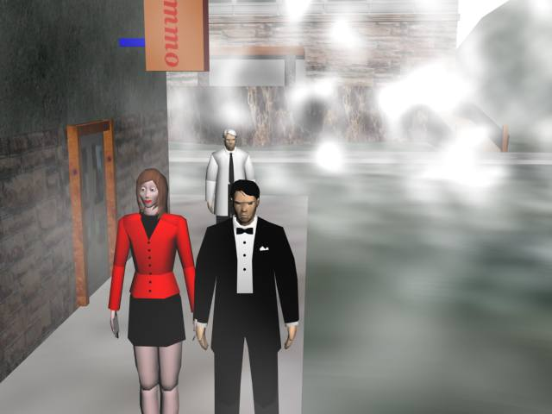
After finding Jane and explaining what happened, you once again thank John and leave, not knowing what to do next. You receive a communication from the aliens. Being aware of your discovery, they offer to give you back your life in exchange for the data you’ve managed to collect.

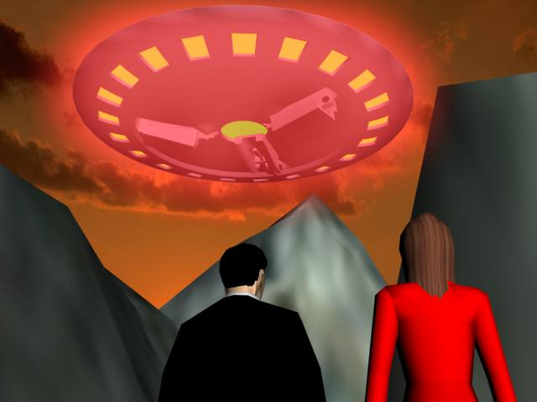
Not really have much of a choice, you agree to their terms. With Jane in hand, you meet the aliens near their ship, where they offer you an “apology” and quickly take off into the night sky, leaving both of your memories of recent events wiped.

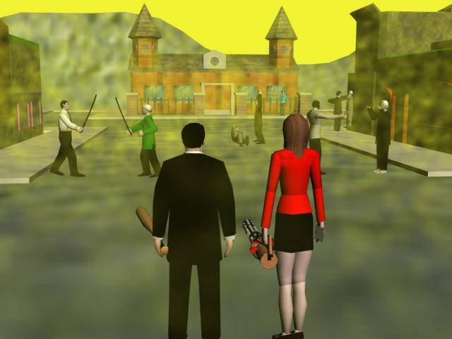
After standing there together in the dark for a few minutes, not knowing how you got there, you start to realize two things: how much you mean to each other and the fact that its Monday. Its payday since most banks are open for business. You survey your fellow citizens going about their lives, pick some weapons lying around, and head off to the nearest bank.

THE END

